Algebra 1: Unit 9, Lesson 9

- Determine the values of $a$, $b$, and $c$ that should be used to solve the equation $7x^{2}+14x-6=-x^{2}+x-11$ using the quadratic formula.
$a=8$, $b=13$, $c=5$

- Andrea solved the equation $x^{2}-x-1=0$ using the quadratic formula. Her incomplete solution is shown.
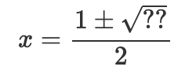
What is the missing value under the square root?

$$5$$

- Amaya is solving an equation using the quadratic formula. Her incomplete work is shown.
$$x=\frac{-8±\sqrt{64-4(1)(-2)}}{2}$$
$$x=\frac{-8±\sqrt{72}}{2}$$
$$x=\frac{-8±6\sqrt{2}}{2}$$

_______________________
Complete the last step of her work.

$$x=-4±3\sqrt{2}$$

